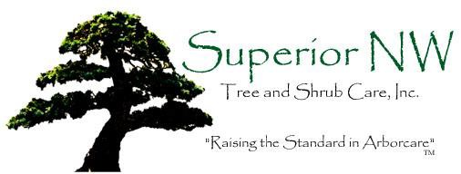

Enterprises

November 16, 2021

Project: Updated pre-construction assessment for lot re-development at 4001 W Mercer Way, Mercer Island, WA. Parcel number 3623500365.

Contact: Mark Wischman – AW Property Group LLC PO Box 500, Mercer Island, WA 98040
Phone – 206 909 5559 Email Mark@wischmanmgt.com

Objectives: Evaluate health of existing trees and establish criteria for the preservation of those to be retained.

Description: The 4001 property was recently purchased in April 2019 and the new owners would like to redesign the lot with thought to development. As part of that process they were informed by the City of Mercer Island that they would need a full tree assessment. Tree Harmony Arborists was contacted who in turn asked Superior NW to provide the assessment.

The existing house was built in 1946 and few if any significant changes have occurred to the lot since that time. All the trees present on the property have grown up in place since that time. This is a large parcel, nearly three-quarters of an acre in size, and it shares two sides with City right- of-ways. It sits on the upper west side of Mercer Island quite close to Lake Washington.

Site visits were made during late May of 2019 and the trees were assessed as to their health, stability, and overall suitability for retention. The following itemized list begins at the NW corner of the existing driveway and includes trees standing on the right-of-ways. The trees are shown in and their numerical designations are reflected in Figure 1. Diameters were measured at the standard height of 54” above grade (DSH) during the 2019 site visits. Heights were estimated.

- Douglas Fir (Pseudotsuga menziesii) 29.5” DSH, 85’ tall standing in the corner
of the main drive and the entrance drive. There has been recent root disturbance within 4’ of the base of the tree on its north side (Figure 2) from when the City of Mercer Island repaved the main entrance drive in 2018. A fungal fruiting body (most likely Heterobasidion annosum) is growing on the north face at the base (Figure 3). The tree is in advanced decline and exhibits limited to no new growth, die back and dead branches throughout the canopy, and weak color and shown in Figure 4. A large Big Leaf maple and another Douglas fir were removed at the time of the paving event.
Both were around 6’ away from this tree. Four evergreen saplings were planted in the space between this tree and the #2 fir. The fir was previously tagged as #115. It was removed in 2020 by the City of Mercer Island.

- Douglas fir 36” DSH, 90’ tall standing 19’ SSE of the #1 tree and 4’ W of the entrance drive which was newly paved (Figure 5). The tree has abnormal basal structure. It is in below average condition with weak color and limited new growth and normal amounts of deadwood present. The majority of its canopy is on the south side mostly likely due to phototropism and canopy pressure from the removed maple.

- Big Leaf Maple stub (Acer macrophyllum) 20” DSH, which broke off near the
16’ level. It stands 8’ S of the #2 fir and only has epicormic growth along the column.

- Flowering Plum (Prunus cerasiferas) 12” DSH, 25’ tall, extending close to 40’
at a 45 degree angle to the south and spreading 14’ to the east and west. There are numerous epicormic verticals along the stem. The tree crowds significantly into the #6 Oregon Ash, rubbing on its main stem and scaffolds. It is in fair health but has weak structure. It stands 14’ west of the #2 fir.

- Hawthorn (Crataegus sp) 10” DSH, 28’ tall, 10’ spread mainly to the west. It stands 3’ WSW of the #4 plum and leans slightly away from it. It exhibits average condition for the species.

- Oregon Ash (Fraxinus latifolia) standing 16’ south of the #4 plum. It has a 14”
DSH, is close to 35’ tall, and its canopy extends almost entirely into the SW quadrant. It reaches 18’ out in the lower scaffolds which have been rubbed by the plum. It exhibits fair health and weak structure. It is growing at the base of a small embankment and close to the corner of an outbuilding which looks to have been present for many years.

- Dual stem Western Red Cedar (Thuja plicata) standing 3’ south of the #6 ash.
It bifurcates fully 30” above its base, each stem is 10” diameter and they twine about each other as they rise. The tree reaches close to 35’ in height and is in fair health but has a significantly weak structure.

- Hawthorn standing 11’ W of the #5 tree and close to the corner of the largest
outbuilding on the property. The tree has an 11” DSH and splits into three stems at the 5’ level. It bends over to the SW and hangs over the building’s roof. It is close to 25’ tall and its canopy is all in the SW quadrant, reaching out for 16’ in the lower scaffolds. It is in fair health. There are multiple saplings growing in its vicinity, mainly hawthorns but a couple of hollies were noted.

- Hawthorn 10” caliper (measured 6” above grade) standing 7’ N of the #8 tree
and 4.5’ S of the main drive. It separates into multiple stems at the 30” mark and most of them grow to the west and south. Those growing north have been cut back from the drive. It is in fair health. Most likely in right-of-way.

- Big Leaf Maple 42” DSH, 75’ tall, 28’ radial spread standing in an island
bordered by a brick retaining wall 12’ to its west, a brick and concrete path 15’ to its east, and the SW corner of the carport which is 15’ NNE of its base as shown in Figure 6. The tree exhibits excellent health and structure for its species and age.

- Extensive holly and laurel mixed hedge running along the east side of the
property (see Figure 1). It is most likely growing in the City right-of-way, it is up to 20’ tall and 14’ wide, and is standing above a small brick retaining wall.

- Flowering plum 18” DSH, 20’ tall, 14’ radial spread standing 12’ E of the
brick and concrete path and 21’ N of the south side property line (Figure 1 and 7). The tree is in decline with advanced decay at its base (Figure 8), multiple cankers along the stem, and several breakout points with visible decay (Figure 9).

- Western Red Cedar 34.5” DSH, 65’ tall standing 20’ N of the south line, 15’
E of a 4’ tall concrete retaining wall, 12’ SW to a floating brick patio with a brick path cutting 45 degrees to the NW from it (Figures 10 and 11). The tree has several laterals which are upturning into subordinate spars (Figure 12). The upper canopy is slightly stunted, the mid-lower has the majority of the canopy density, and its color is fine as shown in Figure 13.

There are numerous other large shrubs and small trees on the site but none reach the City of Mercer Island’s threshold of being significant trees.

Methods: Tree assessment is both an art and a science. To properly perform, an arborist must have an extensive background in biology, tree mechanics, and tree structure that is equal parts academic and field knowledge. It takes years of study to recognize and correctly diagnose the subtle signs trees exhibit before their failure, whether it be partial or total. The process begins with a visual inspection (visual tree assessment, VTA) which is followed up as necessary with soundings, core testing, and/or other detection means. Each tree is examined and evaluated according to several factors including species type, size, vigor, injuries present, root and grade disturbance, deadwood, location and extent of decay, stem taper, exposure, and targets that are at risk.

The International Society of Arboriculture (ISA) spent a number of years developing a Best Management Practices bulletin to aid in their tree risk assessment program. Their methodology supersedes any and all other systems which may be currently in use. While focusing on a qualitative analysis the program is still based on the three primary aspects of tree risk; failure potential, size of part failing (potential of damage from impact), and target rating.

The aspects are scaled as follows. Failure potential (FP) can be imminent, probable, possible, or improbable. Target rating (T) is based on frequency of occupancy and is listed as very low, low, medium, or high. Selections are made in each of the first two categories and a likelihood of target impact found. It can be rated as unlikely, somewhat likely, likely, or very likely as shown in Figure 14. Obviously a level of null risk does not exist if a tree is present. For practical purposes however, arborists assume that if there is no target, the tree poses little or no risk.

The consequences of the failure, usually a function of size of the failed part, are listed as negligible, minor, significant, or severe. Combining the likelihood of a tree failure event with the consequences of that event allows a trained arborist to assign a level of risk to a given tree’s situation. There are four risk categories within the model; Low, Moderate, High, or Extreme. The highest level, extreme, can only be assigned when the likelihood of failure and impact is high (very likely) and the consequences are severe (Figure 15).

Risk Assessments: The targets within range of a tree differ according to the failure types. A branch falling out of a tree generally does not reach much farther out then the diameter of the canopy itself. Heavy winds may carry a branch sidewise for some distance but the range is directly correlated to the height of the break in the tree. Scaffold failures reach out to no more than 20% past their length. Hence the end of a 20’ leader has the potential to hit something 24’ away. A failure occurring mid stem can reach targets up to 10% beyond its length with factors for wind velocity and fall height modifying this range to some extent. Trees which uproot or
have basal failures cannot strike targets outside their own height in anything less than hurricane force winds.

The #1 Douglas fir was significantly impacted by the 2018 street improvement work. In 2016 it was one of three firs in its location (Figure 16). The pavement for edge of Freeman Avenue/40th Street was 4-5’ away from its base (Figure 17). After the reworking of the street entrance in 2018 the edge was less than 3’ away (Figures 18 and 19). It is likely that the impact was closer to 24” from its base figuring in the cut for the edge forms. The extraction of the third fir’s stump also contributed to the #1 tree’s root damage.

This tree is fully exposed to the region’s storm winds which come in from the south and southwest. These are often magnified by an almost wind tunnel effect the lake creates between the island and mainland Seattle. It now has brown rot fungal bodies at its base and rapidly declining canopy. Taking all this into account the tree has a probable likelihood of catastrophic failure.

It is tall enough to reach the 3883 home to the north, completely across West Mercer Way on its east side, and it will bring down the main power lines no matter which way it falls. This means it has a high likelihood of hitting a significant target when it fails. As West Mercer is a heavily traveled road and there is an offset intersection at this location it is more likely than not that at least one vehicle will be involved when the tree fails. According to the first matrix this makes the tree likely to fail and impact. The tree’s failure would result in significant consequences thus making the #1 fir a high risk for catastrophic failure.

The #1 fir was removed in 2020.

The #2 fir has most of the same issues as the #1 tree. It is not exhibiting as severe of a canopy decline as its sister but it is noticeable. At this moment the tree has a possible likelihood of catastrophic failure and a fairly strong case could be made for a probable likelihood of catastrophic failure. Conservatively it is rated as a moderate risk but even a small change in its circumstances will push it over the edge into the high risk category.

The #4 plum, #6 ash, and #7 cedar all have structural issues giving them probable likelihoods of stem or large scaffold failure. Currently they have a high likelihood of hitting the garden shed to their west. The damage could be significant based on the age and materials of the shed. This makes all three high risks for partial failure.

The #12 plum is in quite poor condition with advanced decay throughout its stem and scaffolds. It has a probable likelihood of stem or large scaffold failure. However it has no real targets within reach and therefore is a low risk.

Construction Impact Analysis: The owners have generated a short plat which retains the existing house on Lot B and crafts a space for a new home on Lot A (Figure 20). In this scenario the existing driveway and carport will be removed along with the garden shed. A fairly deep excavation will have to be made to create a building pad. The new house will likely be built into the existing slope with tall concrete walls formed out for the lower story. A full 10’ of space around the perimeter of the house location will have to be accounted for to allow safe building space for forms and retention walls.

Typically there are two impact zones on construction sites, primary and secondary. The primary area includes the environs immediately within the boundaries of the proposed new construction, the demolition areas, and the regions within ten feet of those boundaries. According to the proposed plan the #2, #3, #6, and #7 trees are located in this zone. The first two because of the removal of the existing driveway. The last two because of the demolition of the existing green house. Trees #3, #6, and #7 tree will be removed during the demolition process but the #2 fir is slated to be retained and will be discussed below.

The secondary impact zone includes the trees standing more than 10’ outside the immediate impact regions which have root systems extending within the construction area. This region, the Critical Root Zone (CRZ), is a radial area extending out from the tree a distance equal to one foot per inch of diameter. For example, the #2 fir, with a 36” DSH, has a theoretical 36’ radial CRZ. On this site only the #10 tree stands such that its CRZ could be disturbed by the proposed construction work. By default the #2 tree is included in this group.

Discussion: The saplings growing around and between the trees on the north side of the lot should be selectively culled to create proper growing space. This will ensure a healthy and stable long term canopy.

Although the #12 plum is not within the construction impact region it is not worth putting much energy into preserving. Weight reduction at the extremities is the minimum required. Removal would not be a terrible idea.

The #2 fir has already experienced a degree of impact from the City road improvement work and is exhibiting signs of stress because of it. Great care will have to be taken when removing the driveway. The fir likely has roots reaching beneath and they can be easily damaged. This work should be completed under arborist oversite. Once the asphalt is removed it would help the tree to do a deep root feed thereby providing a means to combat stress and at the same time decompacting the soil. Covering the newly exposed area with 6-8” of arbormulch would be an excellent idea.

Protection fencing for the #2 tree will have to be set up after the driveway is removed. It should be set against the brick retaining wall on the far side of the driveway at least 28’ from the base of the tree and then brought back past where the NE corner of the greenhouse had been to within 10’ of the #4 and #5 trees. It should turn down slope and cross 10’ out from the #8 tree and then curve around it at the limit of its CRZ and continue to the edge of the road.

Fencing for the #10 tree can be set along the top of the brick wall for its length. An arborist will have to oversee the demolition of the carport (if it will be) as it much of it stands inside the maple’s CRZ. It is doubtful the tree has roots beneath the edifice but it is highly likely they wrap close in to the concrete. Once the carport is removed the exposed soil should be covered in 6-8” of arbormulch.

No vehicles can park within the protection area and no materials can be stored within. A table summarizing the removed and retained trees is shown in Figure 21.

Waiver of Liability: Because the science of tree assessment is constantly broadening its understanding, it cannot be said to be an exact science. Every tree is different and performing tree risk assessment is a continual learning process. Many variables beyond the control, or immediate knowledge, of the arborist involved may adversely affect a tree and cause its premature failure. Internal cracks and faults, undetectable root rot, unexposed construction damage, interior decay, and even nutrient deficiencies can be debilitating factors. Changes in circumstance and condition can also lead to a tree’s rapid deterioration and resulting instability.
All trees have a risk of failure. As they increase in stature and mass their risk of breakdown also increases, eventual failure is inevitable.

While every effort has been taken to provide the most thorough and accurate snapshot of the
trees’ health, it is just that, a snapshot, a frozen moment in time. These findings do not guarantee future safety nor are they predictions of imminent events. It is the responsibility of the property owner to adequately care for the tree(s) in question by utilizing the proper professionals and to schedule future assessments in a timely fashion.

This report and all attachments, enclosures, and references, are confidential and are for the use of Mark Wischman; AW Property Group, LLC; JJW Properties, LLC; Angiuli Pacific Residence Trust and their representatives only. They may not be reproduced, used in any way, or disseminated in any form without the prior consent of the client concerned.

Anthony Moran, BS ISA Certified Arborist
Qualified Tree Risk Assessor #PN-5847A

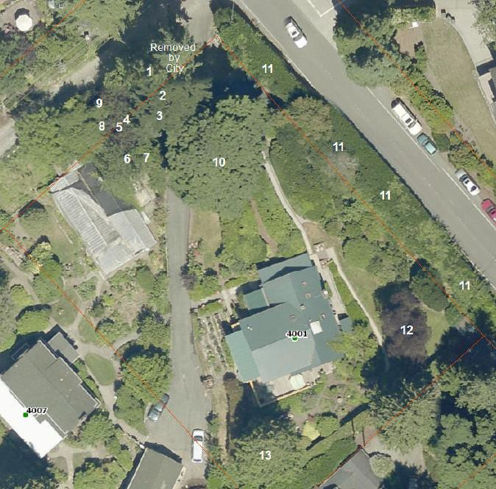

Figure 1. Aerial photo showing rough locations of trees. White numerals match those listed in the Description section.

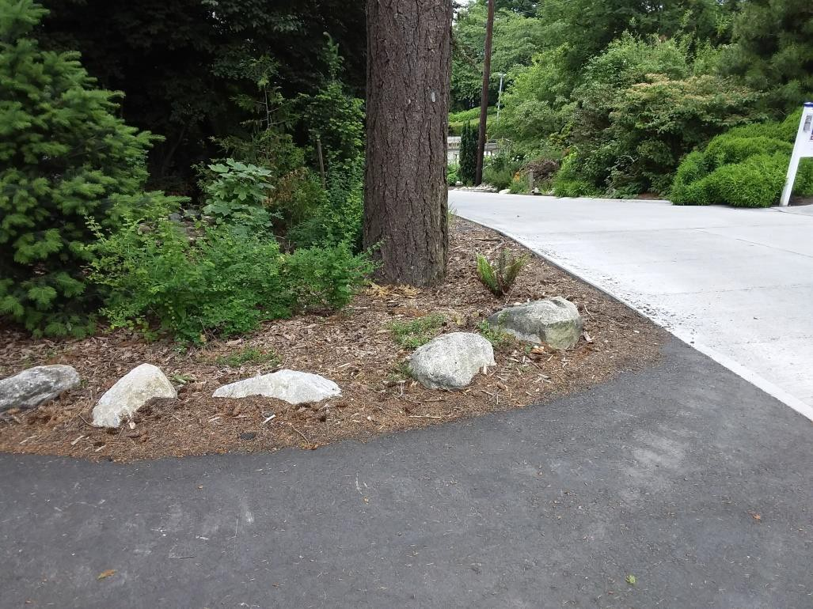

Figure 2. Photo of base of #1 fir showing repaving encroachment.
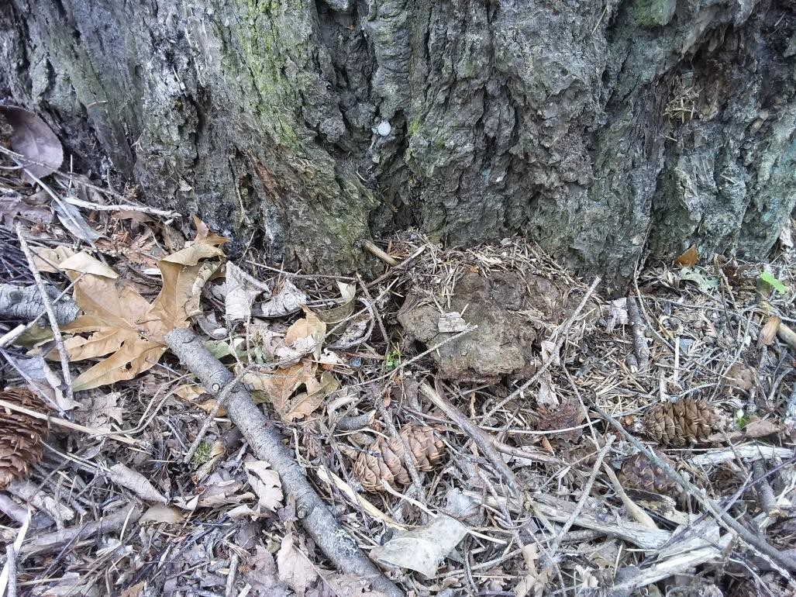

Figure 3. Photo of fungal fruiting body at base of #1 fir.

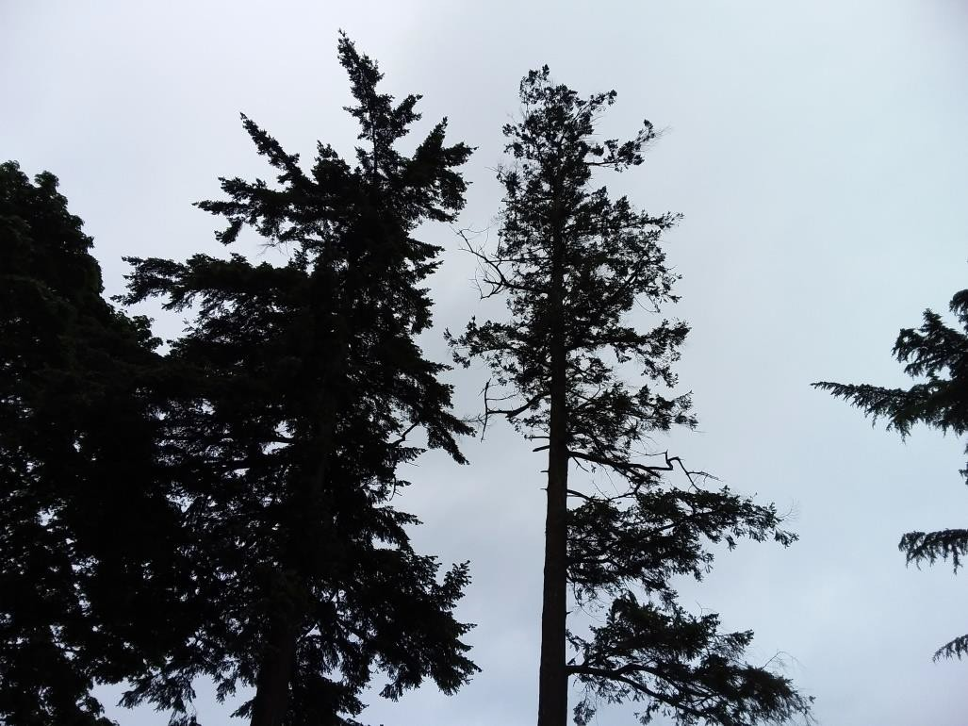
Figure 4. Photo of canopy of the #1 fir. Compare to density of #2 tree. This tree has been removed since the original report was written in 2019.

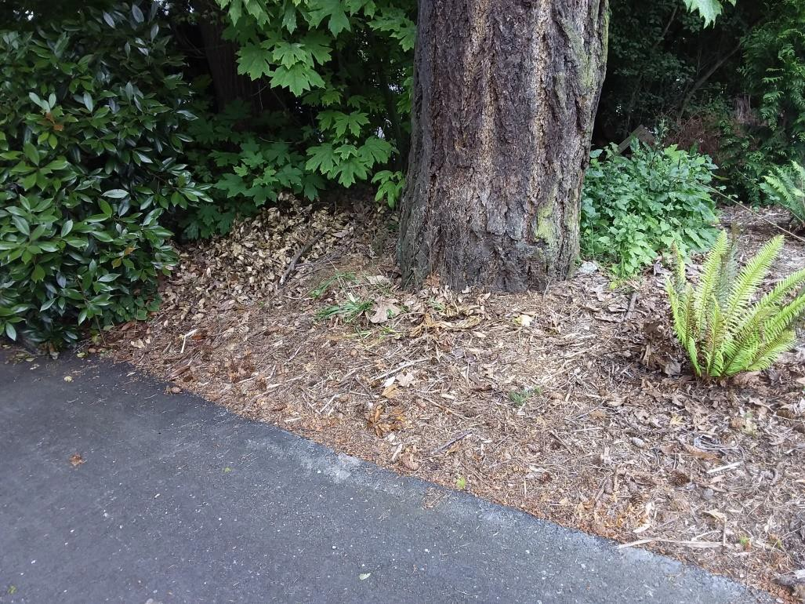
Figure 5. Photo of base of #2 fir showing malformation and proximity of the new pavement.

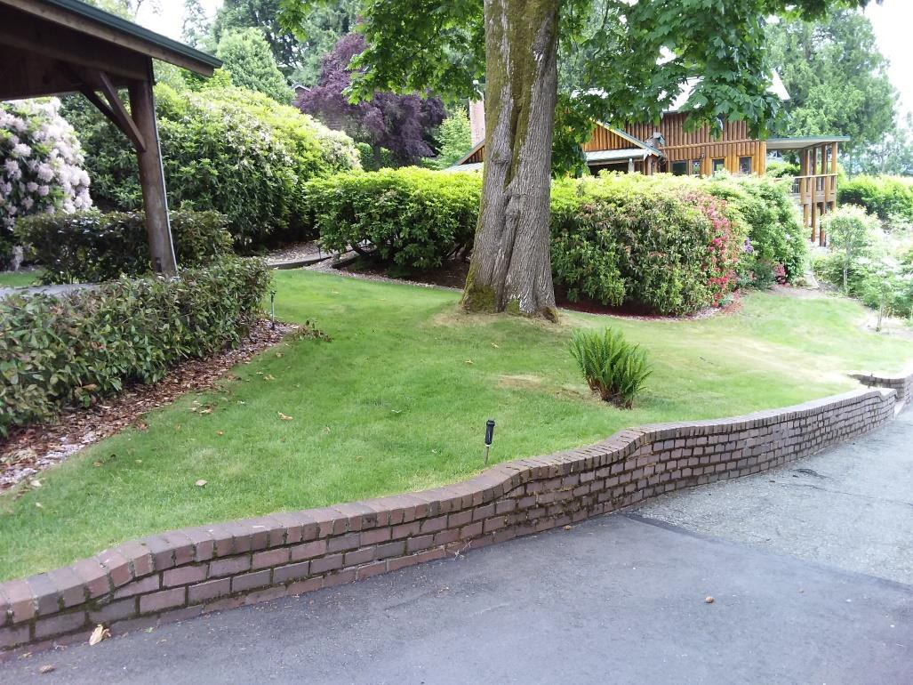
Figure 6. Photo of the large maple standing in its ‘island’.

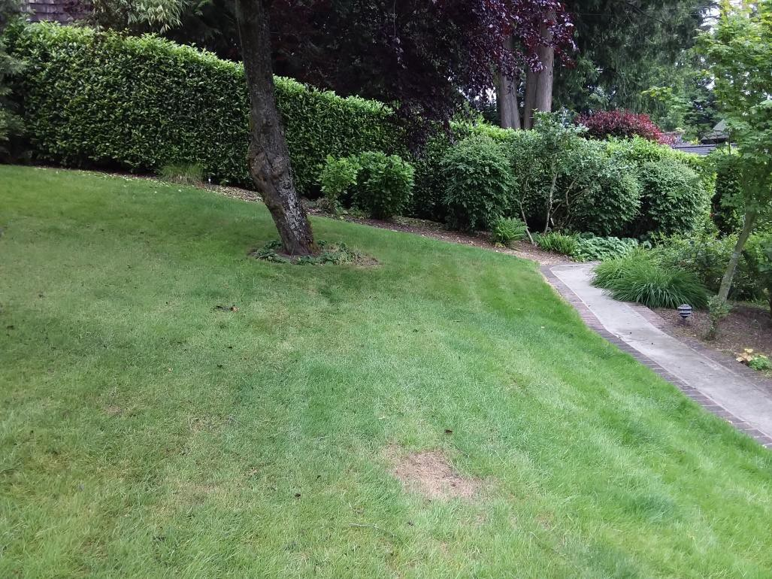
Figure 7. Photo showing placement of #12 plum.

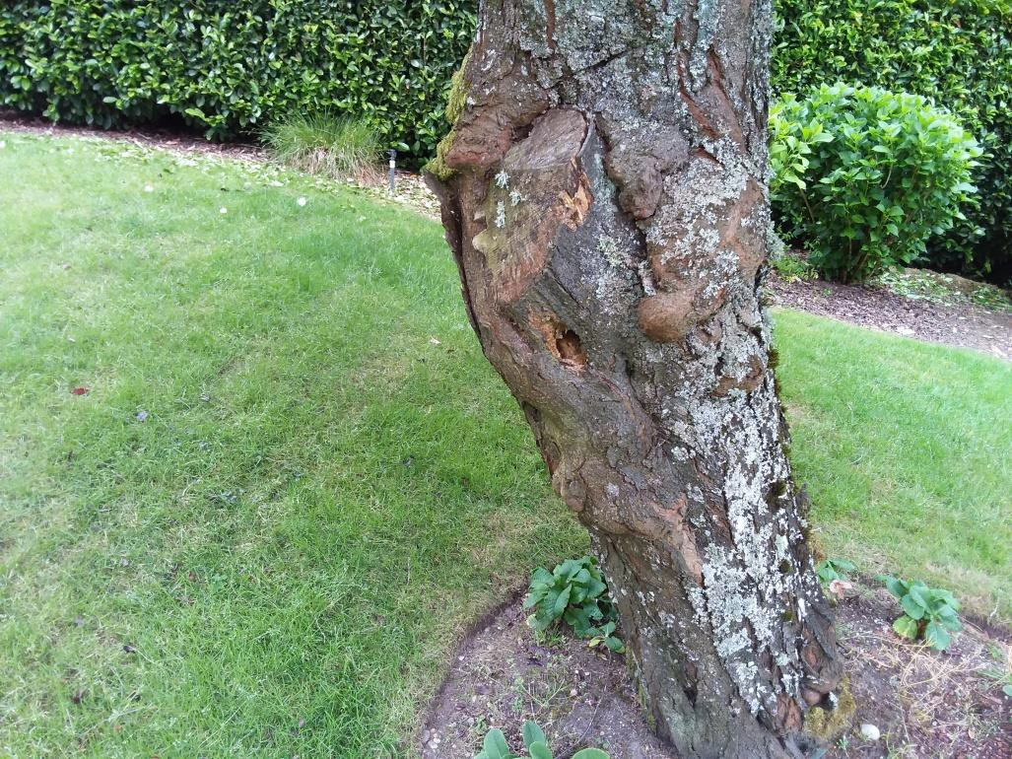
Figure 8. Photo of base of the #12 plum showing decay and cankers.

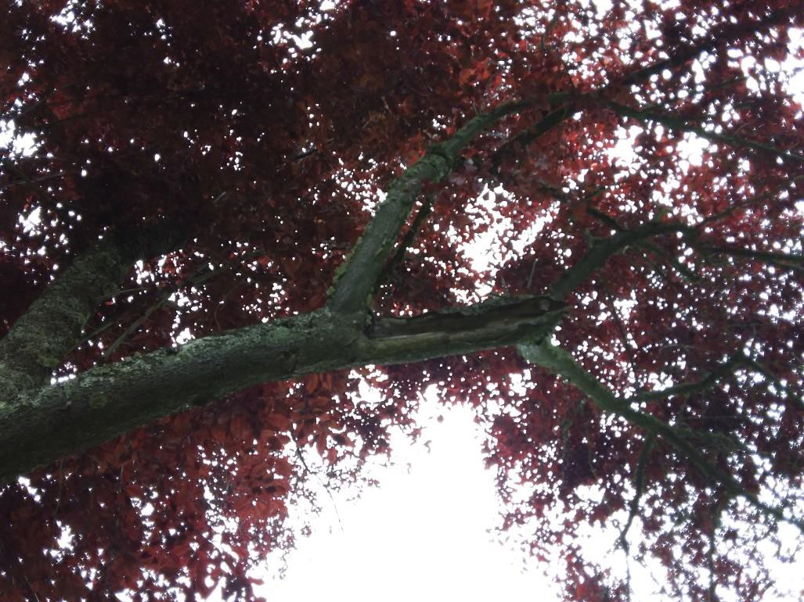
Figure 9. Photo of breakout point with associated decay.

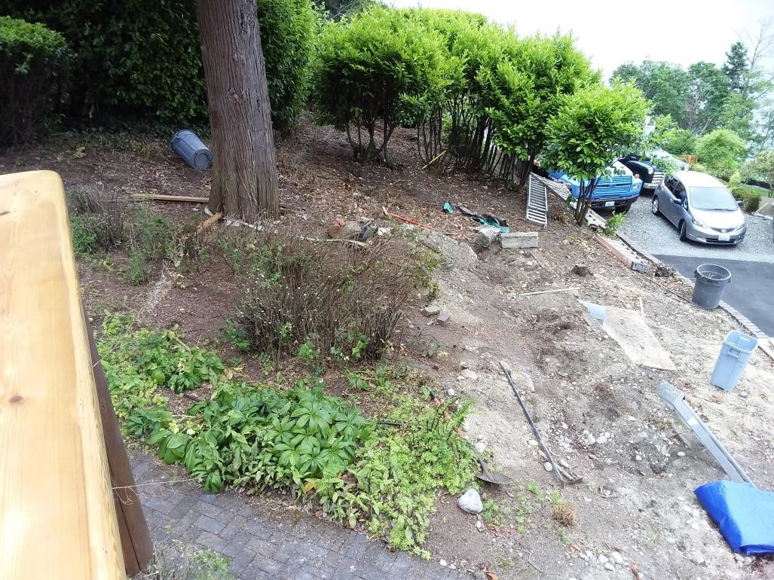
Figure 10. Photo showing the location of the retaining wall on the west side of the #13 cedar (black dashed line).

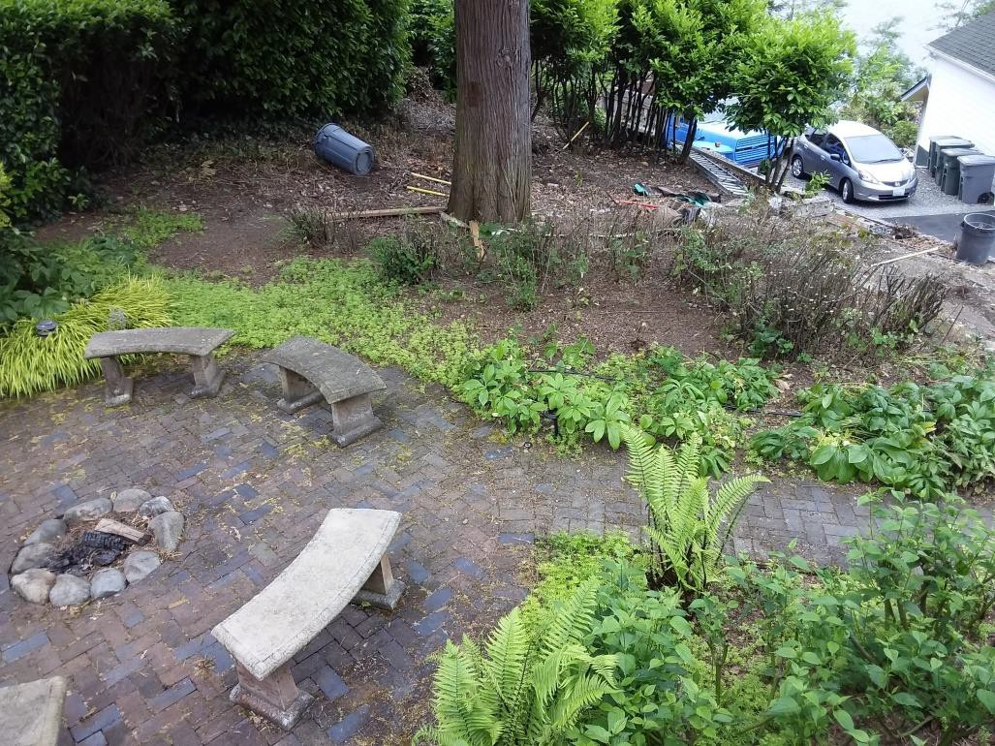
Figure 11. Photo showing layout around the base of the #13 tree.

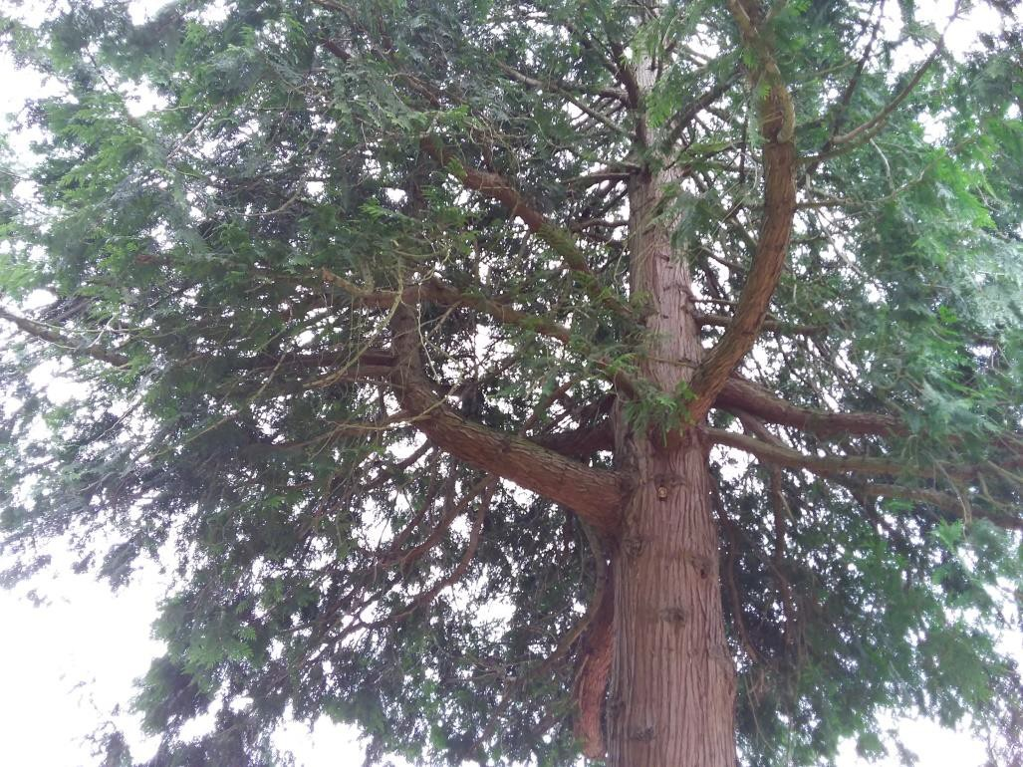
Figure 12. Photo looking up into the lower canopy of the cedar. The upturning lower spars are clearly visible.

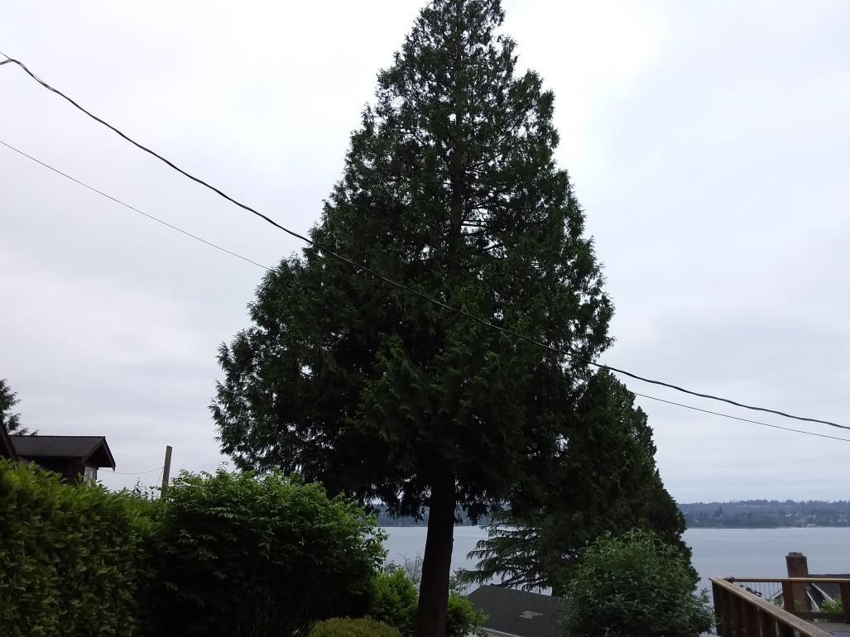
Figure 13. Photo of canopy formation on #13 cedar.

Figure 14. The matrix used to estimate the likelihood of a tree failure impacting a specific target.

Likelihood of Failure | Likelihood of Impacting Target
Likelihood of Failure | Very Low | Low | Medium | High
Imminent | Unlikely | Somewhat Likely | Likely | Very likely
Probable | Unlikely | Unlikely | Somewhat Likely | Likely
Possible | Unlikely | Unlikely | Unlikely | Somewhat Likely
Improbable | Unlikely | Unlikely | Unlikely | Unlikely

Figure 15. Risk rating matrix showing the level of risk as the combination of likelihood of a tree failing and impacting a specific target, and severity of the associated consequences.

Likelihood of Failure  and Impact | Consequences
Likelihood of Failure  and Impact | Negligible | Minor | Significant | Severe
Very likely | Low | Moderate | High | Extreme
Likely | Low | Moderate | High | High
Somewhat likely | Low | Low | Moderate | Moderate
Unlikely | Low | Low | Low | Low

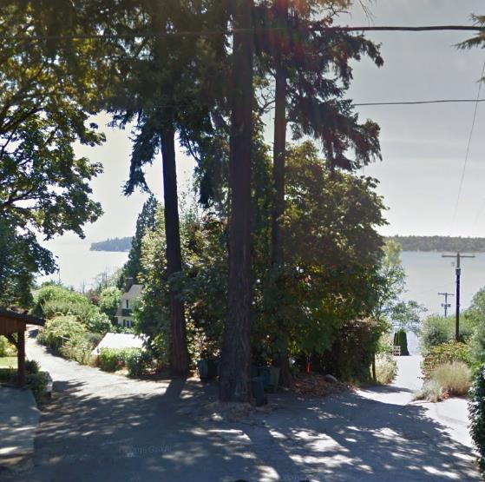
Figure 16. Google Street view image from August 2016 showing the three firs present.

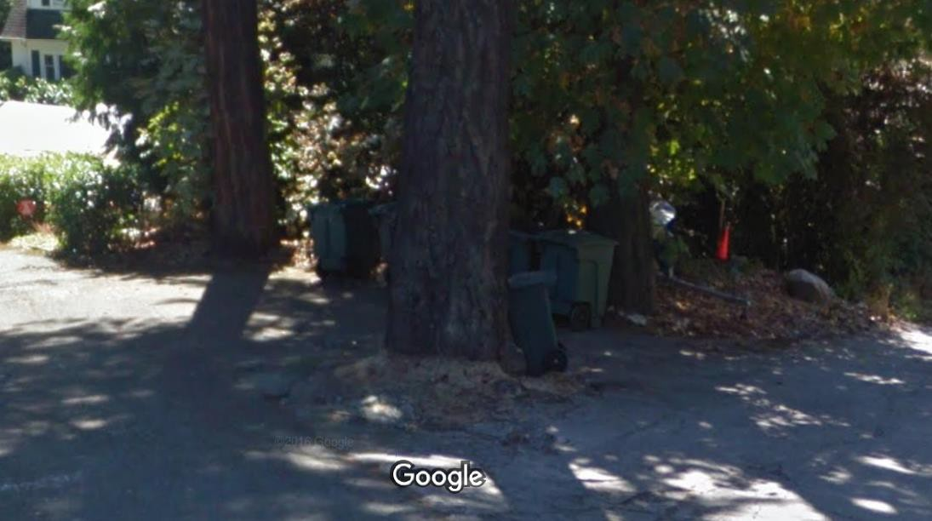
Figure 17. Close up of the bases of the three firs showing how the pavement wrapped around the trees. Note the distance that the edge of the road is from the #1 fir.

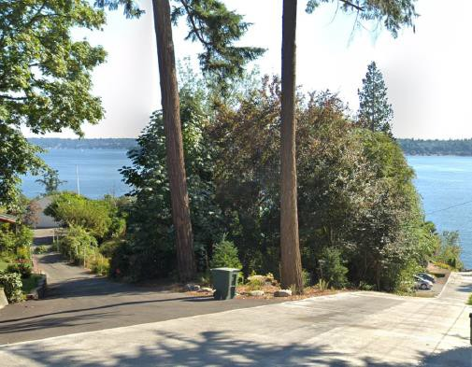
Figure 18. Street View image from July 2018 showing the new layout of the Freeman Avenue/40th Street entrance.

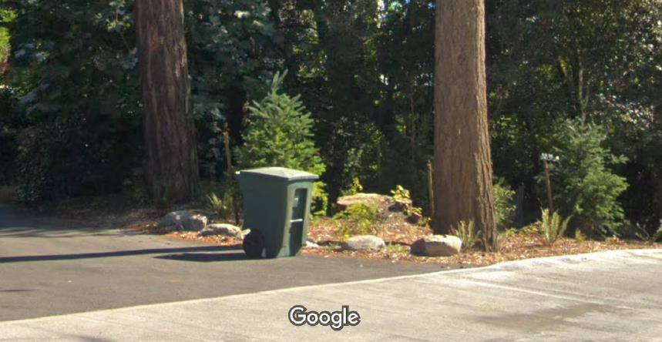
Figure 19. Close up of the image showing the new proximity of the of the street edge to the #1 fir and the driveway entrance to the #2 fir.

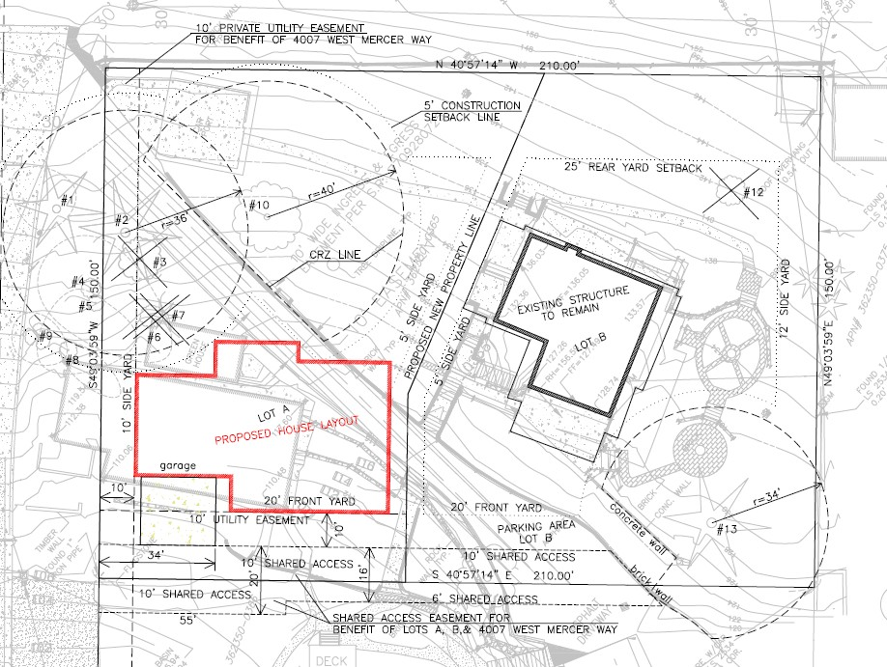
Figure 20. Excerpt from the proposed plan set showing the new property layout.

Number | Species | DSH |  |  | Retain | Condition | In  ROW | Lot A | Lot B
 |  | 36" or > | 24"  or > | 10"  or  >
1 | Douglas Fir |  | 29.5 |  | no | poor | yes
2 | Douglas Fir | 36 |  |  | yes | below  average |  | a
3 | Big Leaf  Maple |  |  | 20 | no | poor |  | a
4 | Flowering  Plum |  |  | 12 | yes | below  average |  | a
5 | Hawthorne |  |  | 10 | yes | fair |  | a
6 | Oregon Ash |  |  | 14 | no | below  average |  | a
7 | Western Red  Cedar |  |  | 15 | no | below  average |  | a
8 | Hawthorne |  |  | 11 | yes | fair | yes
9 | Hawthorne |  |  | 10 | yes | fair | yes
10 | Big Leaf  Maple | 42 |  |  | yes | excellent |  | a
11 | Holly/Laurel  Hedge |  |  | yes | yes | good | yes | a | b
12 | Flowering  Plum |  |  | 15 | no | weak |  |  | b
13 | Western Red  Cedar |  | 34.5 |  | yes | below  average |  |  | b

Figure 21. Tree table.

